**Matlab Code for Draw Cicle using Distance Measure:**

radius = 10; % Radius of the circle

center = [0, 0]; % Center of the circle (x, y)

gridSize = 20; % Grid size (for visualization)

% Create a grid of points

[x, y] = meshgrid(-gridSize:gridSize, -gridSize:gridSize);

% Calculate the distance of each point from the center

distances = sqrt((x - center(1)).^2 + (y - center(2)).^2);

% Create a mask for points that lie on the circle

circleMask = abs(distances - radius) < 0.5; % Allowable margin for plotting

% Plot the circle

figure;

hold on;

imagesc(-gridSize:gridSize, -gridSize:gridSize, circleMask); % Display the circle mask

colormap(gray);

axis equal;

title('Circle Using Distance Measure');

xlabel('X');

ylabel('Y');

hold off;

imshow;

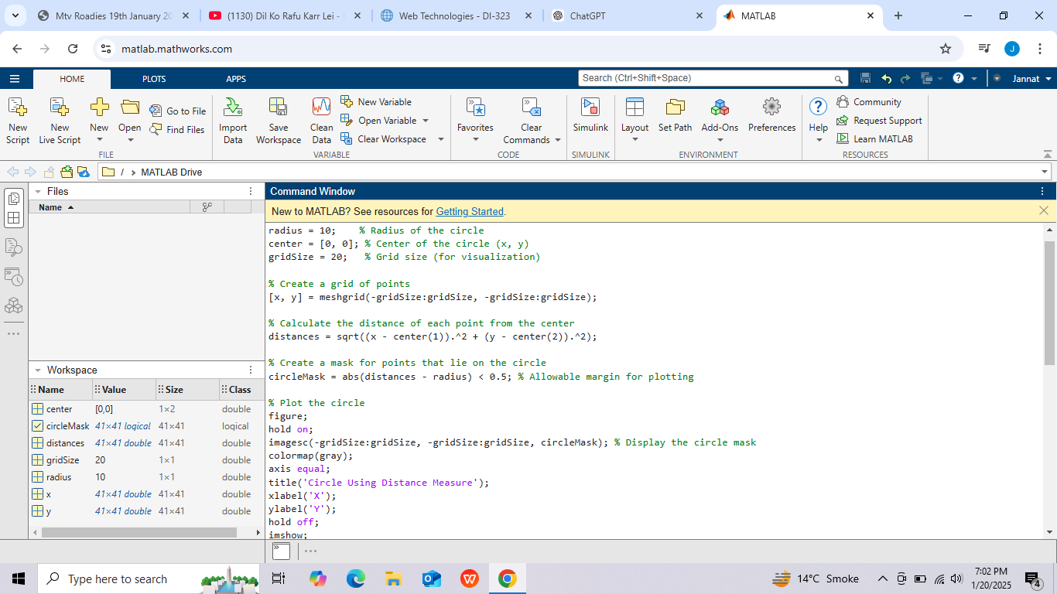

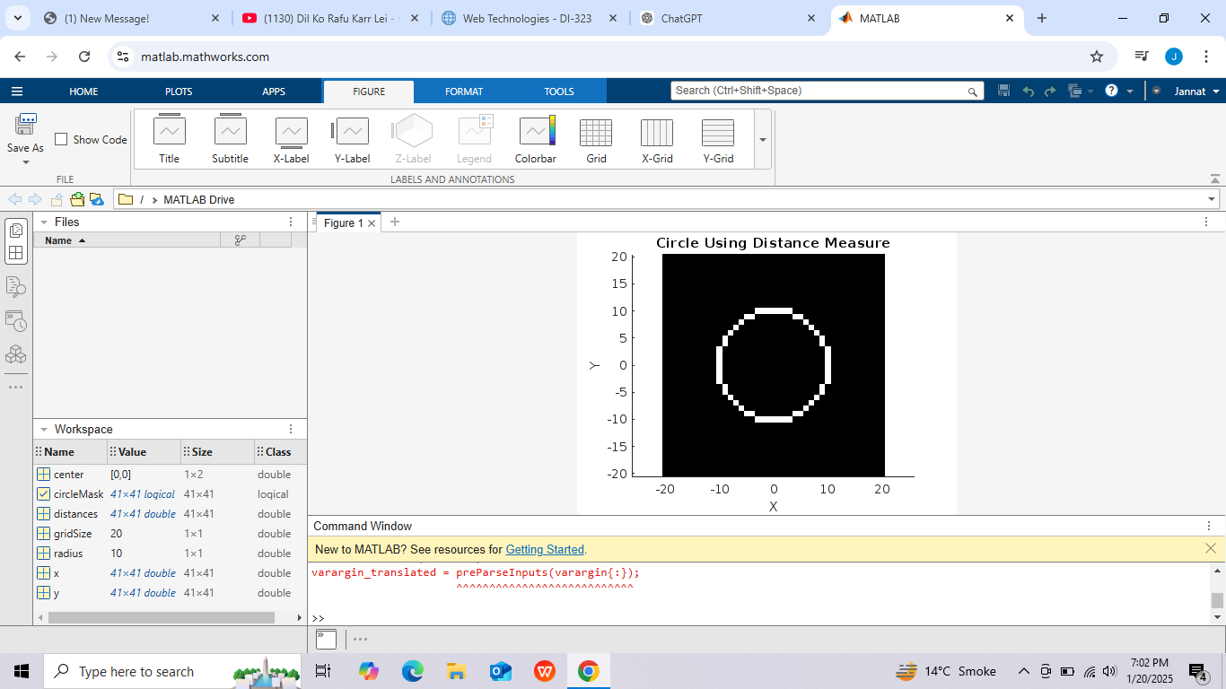

**Explanation:**

* **Grid Creation:**

The meshgrid function creates a grid of points for the given range.

* **Distance Calculation:**

Each point's distance from the circle's center is calculated using the Euclidean distance formula.

* **Masking:**

A logical mask is created for points whose distance is close to the radius, allowing a small margin for visualization.

* **Plotting:**

The circle is displayed using the imagesc function, where the mask highlights the circle's boundary.

This approach is flexible and works well for visualizing a circle on a 2D grid.